**public** **class** StringEx

{

**public** **static** **void** show()

{

String s="Welcome to Java World";

String s1="Welcome";

String s3="HELLO";

System.***out***.println(" Character at 5th position:" + s.charAt(5));

System.***out***.println(s.compareToIgnoreCase(s1));

System.***out***.println(s1+" Let us learn");

System.***out***.println(s.indexOf('a'));

System.***out***.println("Replace String:" + s.replaceAll(" a ", " e "));

System.***out***.println(s.substring(4, 10));

System.***out***.println(s3.toLowerCase());

}

**public** **static** **void** main(String[] args)

{

*show*();

}

}

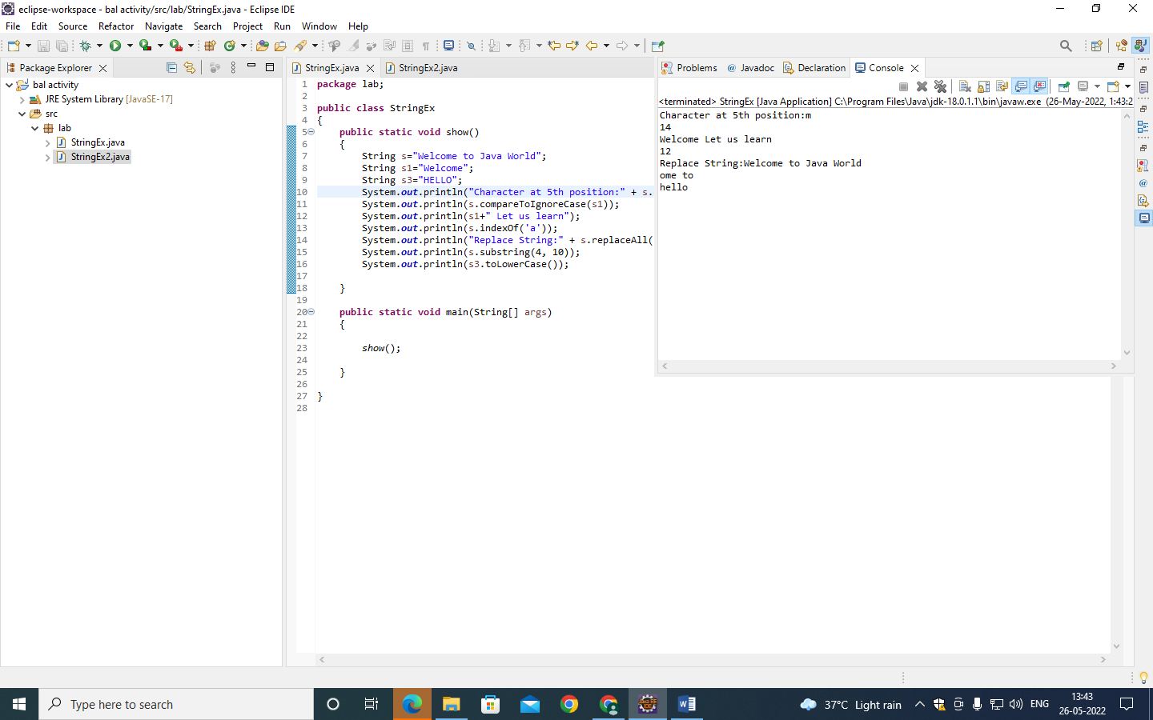

Problem statement 2:

**public** **class** StringEx2

{

**public** **static** **void** display()

{

StringBuffer s = **new** StringBuffer("Good Morning");

StringBuffer s1= **new** StringBuffer("Buffer");

s.append(" This is a sample program");

System.***out***.println("String is :" + s);

s.insert(21, 'o');

System.***out***.println("Insert is :" + s );

s.reverse();

System.***out***.println("Reverse is :" + s);

s1.replace(0, 6,"Builder");

System.***out***.println("Replace is :" + s1);

}

**public** **static** **void** main(String[] args)

{

*display*();

}

}

